33.54: a) n decreases with increasing , so n is smaller for red than for blue. So beam a is the red one.
b) The separation of the emerging beams is given by some elementary geometry.
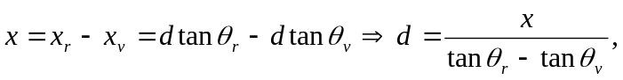 where x is the vertical beam separation as they emerge from the glass 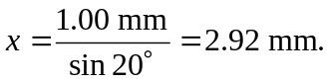From the ray geometry, we also have
